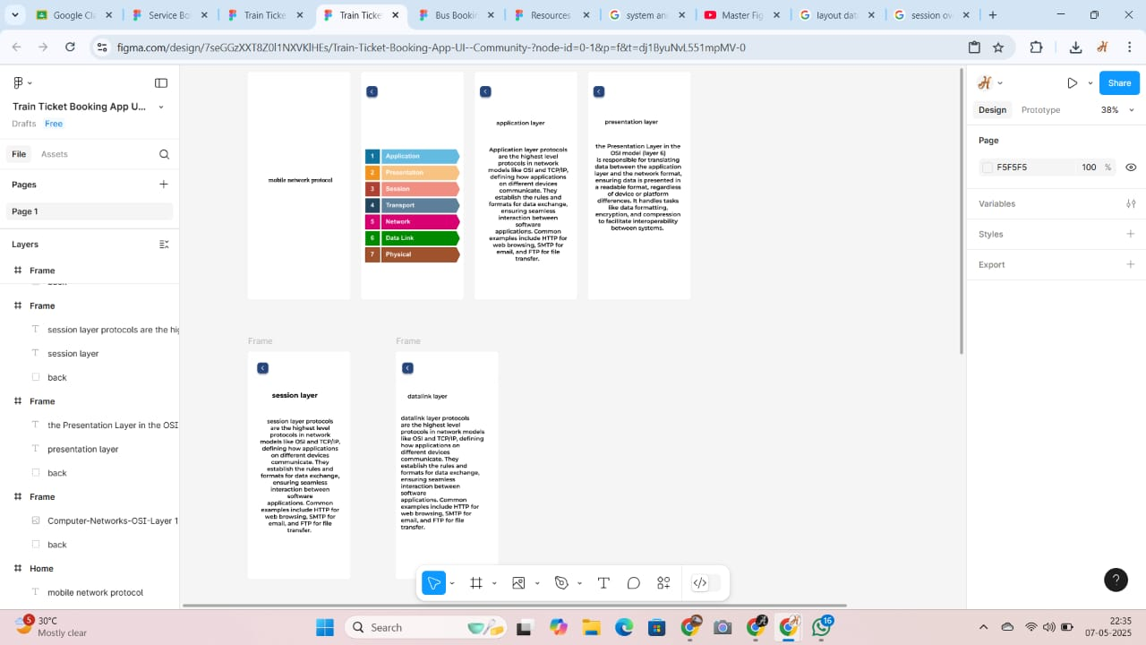

EXPERIMENT N0 4

**Create a visual representation in Figma highlighting the key elements of mobile network protocol stacks.**